**Al-Azhar University- Gaza**



**Faculty of Engineering & Information Technology Department of Software Engineering**

**Software Design**

SRS Document for Places-near-me Software

Prepared by:

Sally Mohammed Abd-Alatti

Supervised by:

Eng.Heba Abu Skhail

### Semester I 2022/2023

# Table of Contents

1. Introduction
   1. Description
   2. Problem Statements
   3. Objectives
   4. Glossary
2. Overall Description
   1. Actors
3. Requirement
   1. Functional Requirements
   2. Non-Functional Requirement
4. Use Cases List
5. Use Case description.
6. UML diagrams
   1. Use Case diagram
   2. Class diagram

**1.0.INTRODUCTION**

***1.1.Description***

It's an application to display list of facilities that is near to the user's location and gives information about that facilities , and allow the user to contact with them .

***1.2. Problem Statements***

1- A user do not know the nearest facility of certain category.

2- A user do not know how to reach certain facility.

3- A user in unfamiliar with the location he is in.

4- A user do not know when a certain facility is available.

5- A user do not Know how to contact the facility to ask about info .

***1.3. Objectives***

1- Activating tourism and commerce in the region.

2- Reducing the time required to reach certain facility\ place .

3- Increasing the profit to the facilities owners.

***1.4. Glossary***

|  |  |
| --- | --- |
| **Term** | **Definition** |
| User | Someone is looking for a services (Food - medicine - medical care - accommodation - furniture - clothes - self-care-Book - etc.( |
| Visitor | A user that have checked in a facility . |
| Facility | Is a place that provides some services (Restaurant - hospital - clinic - pharmacy - mall - beauty center - furniture store - library –etc. ) |
| Facility owner | Who runs a place that gives services |
| Facility reception | Who is responsible to welcome visitors and answer there questions |
| Facility admin | Who is controlling the facility profile in the app |

**2.0.Overall Description**

***2.1. Actors***

*2.1.1. Internal Actors:*

1- Facility admin .

2- Regular user

*2.1.2. External Actors:*

1-Ministry of tourism.

**3.0.Requirements**

***3.1.Functional Requirements***

*1-Facility Admin*

Req1:01: The system shall allow the facility admin of the facility to sign up.

Req1:02: The system shall allow the admin of the facility to login.

Req1:03: The system shall allow the admin of the facility to verify the number..

Req1:04: The system should have display list of users that have checked in the facility.

Req1:05: The system should allow the facility admin to view the visitors feedback.

Req1:06: The system shall allow the facility admin to set the status of the facility.

*2-Regular User*

Req2:01: The system shall allow the User to sign up.

Req2:02: The system shall allow the User to login.

Req2:03: The system shall allow the User to verify his\her number.

Req2:04: The system shall allow the user to view list of categories.

Req2:05: The system shul allow the user to select a category from the list.

Req2:06: the system shall display to the user a map with facilities of the selected category.

Req2:07: The system shall allow the user to view list of facilities of the selected category.

Req2:08: The system shall display to the user the nearest facility of the selected category.

Req2:09: The system shall allow the user to search for a certain facility.

Req2:10: The system shall display to the user the profile of selected facility.

Req2:11: The system shall allow the user to call the facility reception.

Req2:12: The user shall view the road to the selected facility.

Req2:13: The system shall allow the user to check in the facility.

Req2:14: The system shall allow the user to give feedback about the facility.

Req2:15: The system shall allow the user to rate the facility.

Req2:16: The user shall view the most rated facility of the selected category.

**3.2.Non-Functional Requirements**

1- **Compatibilit**y :

-The Android application must support devices running on Android version : 10 , 11 , 12

- The IOS application must support devices running on IOS 11

2- **Reliability** :

-The system must perform without lessening in 90 percent of use cases during a month.

3- Performance :

-The places-near-me System shall allow the users to view the facilities map within 3 second . .

4- Portability:

-The system that runs on Android devices must be able to run on IOS devices without any change in its behavior and performance.

5- Availability :

- The system will be available to PS users 99 percent of the time every month.

**4.0 UseCase list**

**4.0.1 Facility admin UseCases :**

-UC1:01: sign up.

- UC1:02: log in.

- UC1:03: verify facility phone number.

- UC1:04: display visitors list.

- UC1:05: view feedbacks.

- UC1:06: set facility status.

-UC1:07: upload facility picture

**4.1.2 Regular user UseCases :**

- UC2:01: sign up.

- UC2:02: log in.

- UC2:03: verify phone number.

- UC2:04: view categories list.

- UC2:05: select category.

- UC2:06: display map.

- UC2:07: display list.

- UC2:08: select a facility.

- UC2:09: display nearest facility.

- UC2:10: display most rated facility.

- UC2:11: search for facility.

- UC2:12: view facility profile.

- UC2:13: call facility.

- UC2:14: display road to the facility.

- UC2:15: rate facility.

- UC2:16: check in facility.

- UC2:17: give feedback.

**5.0 Use Case Description**

|  |  |  |  |
| --- | --- | --- | --- |
| **UC1:01**  **RQ1:01** | Sign up | | **Name** |
| Facility admin | | | **Actor** |
| This use case allows the facility admin to enter the facility information (Name , Phone number , type, brief services, password ,a picture of the intrans) and define the facility location , to create an account to this facility and so that it's registered in the system | | | **Description** |
| Install the app | | | **Pre-Condition** |
| 1-The admin enters the required account information values(Phone number , type, brief services, password,) then locates the facility by GPS , upload the intrans image ,then submit sign up . | | | **Basic Flow** |
| **Description** | | **Title** | **Alternative Path** |
| The system will display an error message | | Invalid information |
| The system will display a message | | The phone number is already exist in the system |
| The account is created successfully  The facility admin will receive the verification code  The admin will be notify that the account is created successfully | | | **Post Condition** |

|  |  |  |  |
| --- | --- | --- | --- |
| **UC1:03**  **RQ1:03** | Verify facility number | | **Name** |
| Facility admin | | | **Actor** |
| Verifying the facility phone number , to insure that this numberis te facility's number. | | | **Description** |
| 1-The app is installed.  2-The facility admin have an account | | | **Pre-Condition** |
| 1-The admin enters the code.  2-The admin select verify the phone number. | | | **Basic Flow** |
| **Description** | | **Title** | **Alternative Path** |
| The system will display an error message  "Invalid phone number" | | Invalid phone number |
| The system will display an error message  ."Wrong code" | | Wrong code |
| The system will display an error message  "This phone number is already exist" | | previously saved phone number to an exist facility account |
| 1-The phone number is saved to the facility account.  2-The facility phone number is verified successfully | | | **Post Condition** |

|  |  |  |
| --- | --- | --- |
| **UC1:06**  **RQ1:06** | Set facility status | **Name** |
| Facility admin | | **Actor** |
| This use case enables the facility admin to change the facilities status (close , open , in soft opening ,official opening ,close for maintanens ) so that users consider. | | **Description** |
| There is an existing account for the facility. | | **Pre-Condition** |
| 1-From the facility profile, the admin chooses the status that he want to switch to .  2-He/she asks the system to switch the status. | | **Basic Flow** |
| None | | **Alternative Path** |
| The status switched\changed | | **Post Condition** |

|  |  |  |  |
| --- | --- | --- | --- |
| **UC2:02**  **RQ2:02** | Log in | | **Name** |
| Regular user | | | **Actor** |
| This use case enables the user to log in his registered account. | | | **Description** |
| 1-The app is installed.  2-Already having an account | | | **Pre-Condition** |
| 1-The user enters his\her email and password.  2-The user click log in | | | **Basic Flow** |
| **Description** | | **Title** | **Alternative Path** |
| 1-when a user entered an email that is not assigned to any account.  2-The system shows that something is wrong . | | Unregistered Email |
| 1-When a user enters an registered email but wrong password.  2-The system shows that something is wrong . | | Wrong password |
| The user successfully logged in | | | **Post Condition** |

|  |  |  |  |
| --- | --- | --- | --- |
| **UC2:06**  **RQ1:1** | Display map | | **Name** |
| User | | | **Actor** |
| This use case enables the User to view a map that with his location in addition to all registered facilities location. | | | **Description** |
| 1-The user already have an account.  2-The user's device is connected to internet.  3-The GPS is enabled. | | | **Pre-Condition** |
| 1-The user asks to view the map of facilities.  2-The system displays a map with the user location and the locations of registered facilities .  3-The user can scroll on the map to show further facilities. | | | **Basic Flow** |
| **Description** | | **Title** | **Alternative Path** |
| 1-The user asks to view the map , but his\her device is cot connected to internet.  2-The system that something went wrong. | | No internet connection |
| 1-The user asks to view the map , but the GPS is not enabled.  2-The system that something went wrong. | | GPS is not enabled |
| The map is displayed. | | | **Post Condition** |

|  |  |  |
| --- | --- | --- |
| **UC2:09**  **RQ1:1** | Display the nearest facilities | **Name** |
| Regular user | | **Actor** |
| This use case makes the system display the nearest facilities of a selected category. | | **Description** |
| Select category | | **Pre-Condition** |
| 1-The user asks to show the nearest n facilities.  2-the user enters the value of n.  3-The user selects the category .  4-The system displays a list of the nearest n facilities | | **Basic Flow** |
| None | | **Alternative Path** |
| A list of the nearest n facilities of a pre-selected category is displayed. | | **Post Condition** |

|  |  |  |
| --- | --- | --- |
| **UC2:12**  **RQ1:1** | View facility profile | **Name** |
| Regular user | | **Actor** |
| This use case enables the user to view the selected facility profile ,that contains the facility intranc picture and some information about that facility (address , phone number , feedbacks , rating .. etc) . | | **Description** |
| Selecting a facility | | **Pre-Condition** |
| The user selects a facility ( by search or map or list ) | | **Basic Flow** |
| None | | **Alternative Path** |
| The facility profile is viewed. | | **Post Condition** |

|  |  |  |  |
| --- | --- | --- | --- |
| **UC1:01**  **RQ1:1** | Display road | | **Name** |
| User | | | **Actor** |
| The system describes \ highlights the road from the user location to the facility | | | **Description** |
| 1-The user already have an account.  2-The user's device is connected to internet.  3-The GPS is enabled. | | | **Pre-Condition** |
| 1-The user selects a facility.  2-The profile of the selected facility is viewed.  3-The user asks to show the road.  4-A map with the highlighted road is displayed. | | | **Basic Flow** |
| **Description** | | **Title** | **Alternative Path** |
| 1-The user to show the road, but his\her device is not connected to internet.  2-The system that something went wrong. | | No internet connection |
| 1-The user to show the road, but the GPS is not enabled.  2-The system that something went wrong. | | GPS is not enabled |
| 1- A map with the highlighted road is displayed.  2-The map may temporerly saved so that the user can reach the facility . | | | **Post Condition** |

|  |  |  |
| --- | --- | --- |
| **UC2:16**  **RQ2:05** | Check in | **Name** |
| Regular user | | **Actor** |
| This use case enables the regular user to check in that facility. | | **Description** |
| None | | **Pre-Condition** |
| 1-The user visits the facility profile  2-he/she check in that facility. | | **Basic Flow** |
| None | | **Alternative Path** |
| The user name will be inserted to the visitors list of the facility. | | **Post Condition** |

|  |  |  |
| --- | --- | --- |
| **UC2:16**  **RQ1:1** | Rate the facility | **Name** |
| Regular user | | **Actor** |
| The system allows the user to rate the facility (from 5) | | **Description** |
| The user have checked in that facility | | **Pre-Condition** |
| 1-The user check in the facility profile  2-The user rates the facility . | | **Basic Flow** |
| None | | **Alternative Path** |
| 1-A notification is send to the facility admin.  2-The general rate will change. | | **Post Condition** |

**6.0 UML Diagrams *6.1. Use case diagram***

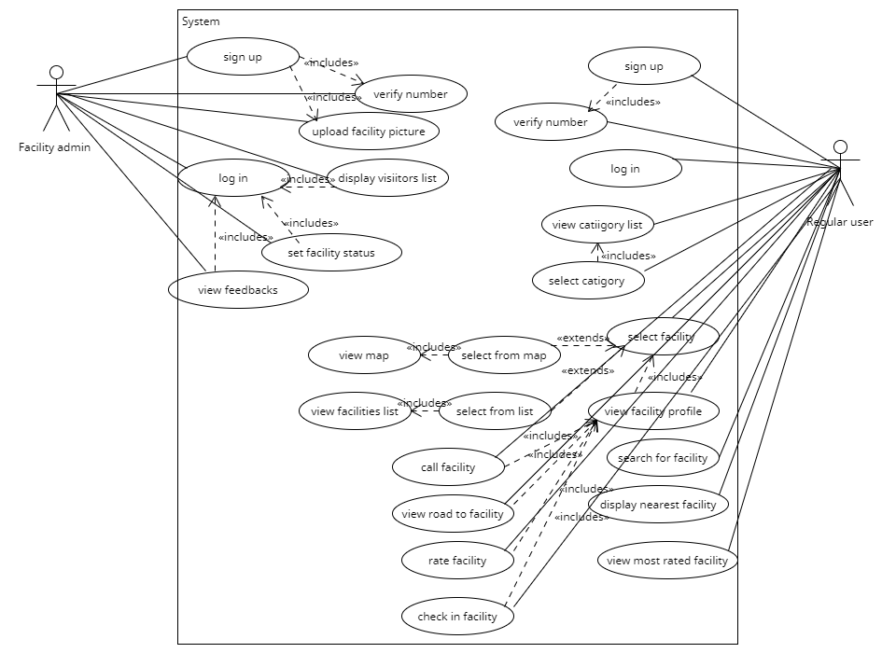

***6.2.Class diagram***

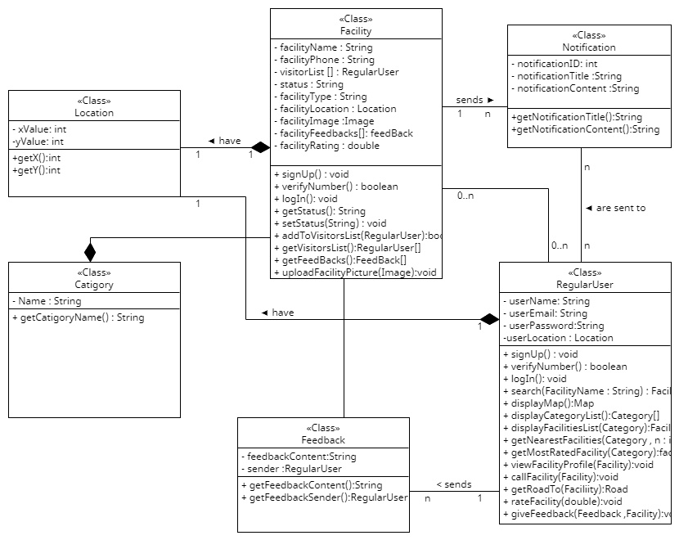

***6.3.CRC***

|  |  |
| --- | --- |
| **Class: <Facility>** | |
| **Collaborators** | **Responsibilities** |
|  | Knows it's name |
|  | Knows it's phone number |
| RegularUser | Knows it's visitors |
|  | Knows it's status |
| Location | Knows it's Location |
|  | Knows it's rate |
|  | Check if it's phone number is verefied |
|  | Sign up |
|  | Log in |
|  | Change it's status |
|  | Upload picture |
| RegularUser | Add visitor to it's visitors list |

|  |  |
| --- | --- |
| **Class: <RegularUser>** | |
| **Collaborators** | **Responsibilities** |
|  | Knows it's name |
|  | Knows it's email |
|  | Knows it's password |
| Location | Knows it's Location |
|  | Check if it's phone number is verefied |
|  | Sign up |
|  | Log in |
| Facility | Search for facility |
| Location , Facility | View map |
| Facility | View a list of facilities |
| Facility | Call facility |
| Road , Facility | View the road to a certain facility |
| Facility | Rate facility |
| Facility , Feedback | Give feedback to a facility |

|  |  |
| --- | --- |
| **Class: <Location>** | |
| **Collaborators** | **Responsibilities** |
|  | Know x value |
|  | Know y value |

|  |  |
| --- | --- |
| **Class: <Road>** | |
| **Collaborators** | **Responsibilities** |
| Location | Knows its destination location |
| Location | Knows its source location |
| Street | Knows its routes |

|  |  |
| --- | --- |
| **Class: <Feedback>** | |
| **Collaborators** | **Responsibilities** |
|  | Knows its content |
| RegularUser | Knows its sender |

|  |  |
| --- | --- |
| **Class: <Street>** | |
| **Collaborators** | **Responsibilities** |
|  | Knows its name |

|  |  |
| --- | --- |
| **Class: <Notification>** | |
| **Collaborators** | **Responsibilities** |
|  | Knows its name |
|  | Knows its title |
|  | Knows its content |

***6.4.Sequence diagram***

6.4.1 Call Facility

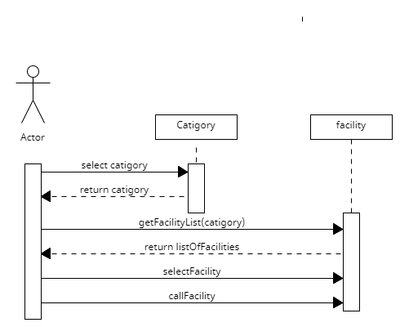

6.4.2 Facility sign up

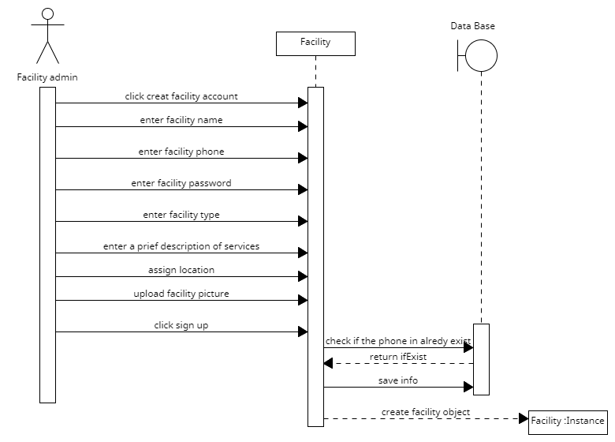

6.4.3 User sign up

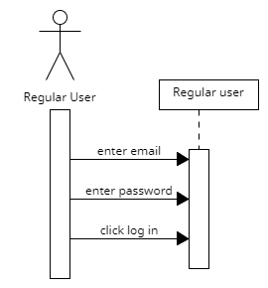

***6.5.Activity diagram***

6.5.1 facility sign up

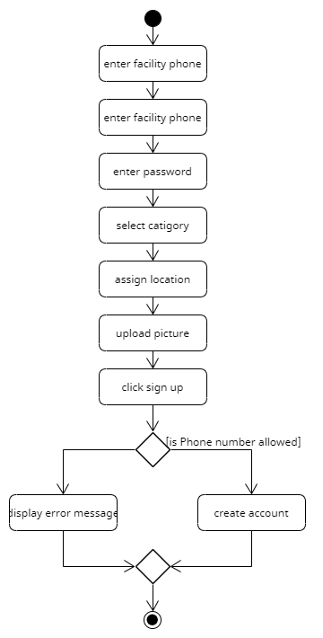

6.5.2 user log in

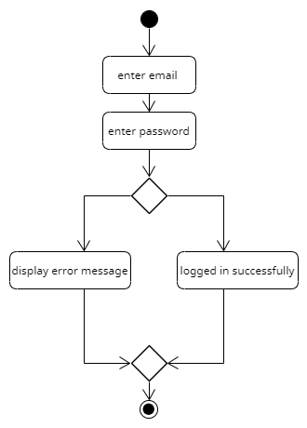

6.5.3 send feedback

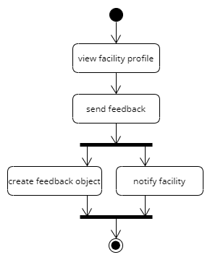

**The architecture style**

=> In this project we could use repository-based architecture ; because the application needs to store and manage large amount of data.

🡺The central repository could be data base.

🡺The application would communicate with the central data through multiple interfaces by performing CRUD operations on data.

🡺**The advantages of using repository-based architecture**

-Support data integrity , data backup and data restoration.

-Reduce overhead of data transfer between data accessors.

-Central data component usually live on a separate server (easier management of info).

🡺**The disadvantages of using repository-based architecture**

**-**The system is heavily reliant on the central data.

-Data accessors are dependent on what gets stored in the data base.

-It's difficult to change the existing data schema.

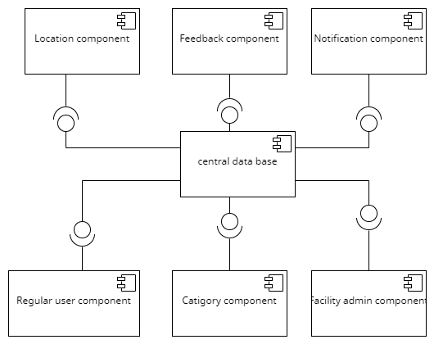

1hall view